THE CHALLENGE
“How might we use AI and emerging technology to transform the way students learn and succeed?”

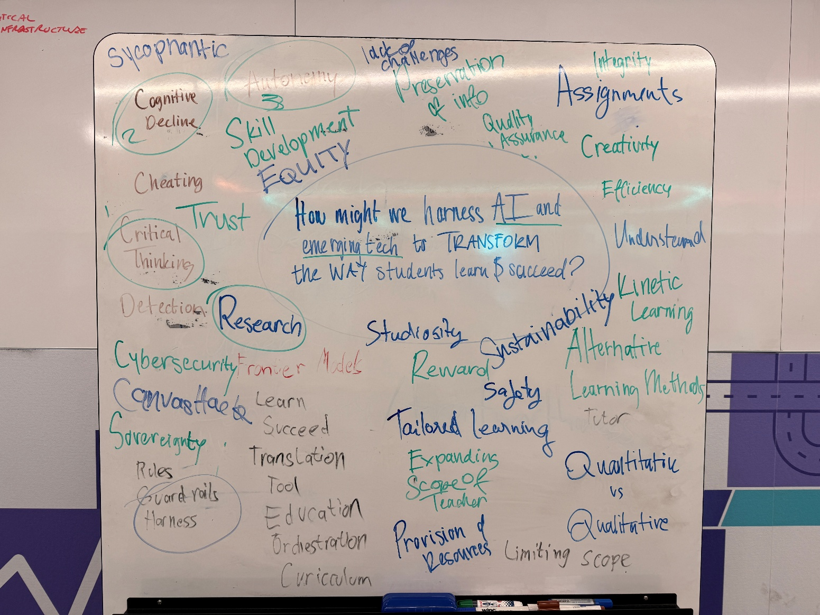

TEAM WORKING AGREEMENT

People and roles
Name | Strengths | Wants to try or grow | Lead role | Backup role
Simone | Research, cybersecurity, design, | More design and software engineering | Research and design (open to any) | Any as needed (after discussion)
Justin | Machine Learning, Research, Design | Research, Web and Dev ops | Anything | Anything
Carlos | Network Infrastructure and Telemetry, Cloud and local based AI and tuning, | Research, Problem thinking, Creative thinking |  | Any as needed

Workspace
Item | Details
File sharing and main workspace | SharePoint and MS Teams: Link here
Main chat channel | Webex and MS Teams  Contacts:  - Simone: u3258385@uni.canberra.edu.au (Teams); Simone.Chitsinde@canberra.edu.au (Webex)  - Justin: u3289054@uni.canberra.edu.au (Teams and Webex)  - Carlos: u3292902@uni.canberra.edu.au (Teams); u3292902@uni.canberra.edu.au (Webex)

BRAINSTORM TOOLKIT

Methods
- How might we - turn the problem into questions, for example "How might we make people trust X?"
- Reverse brainstorm - ask "How could we make this problem worse?", then flip each answer.
- Borrow from another field - ask how a game designer, a librarian or a public health team would solve it. Ask friends, family and colleagues.
- Crazy 8s - fold a page into eight boxes and sketch eight ideas in eight minutes.
- Familiar thing, new place - list tools and habits people already use every day, then ask where else each could apply.
- Combine - pair two ideas from different people and see what the mix looks like.

Idea board
Idea | Whose | The problem it targets | Who benefits
App that has safeguards and harnesses that students have free reign to use any AI model in accordance to University’s policies | Carlos | - Integrity  - Trust | - Students who use multiple AI/ have local models
Extension that provides summaries/ideas or guides the students by reading assignments or other relevant unit documents. | Justin | - Equal Access to systems  - Efficiency  - Sovereignty
An app design in regards to the app if the 1st idea, where the professors can ask the AI on their opinion on how the students used them and/how they prompt their questioning on how they did in using them on the assignment/project (“Did they do foloow up questions?”,”Did they try to understand the overall project”). With the overview of the AI, professors can grade students not on the outcome but how they solved the problem. | Carlos | - Trust  - Cheating  - Succeed | - Professors having an easier way to properly grade students based on the project/instead of grade base (One of the judges liket the idea, Scott)  - Students being graded not on the solution but more on how they solved it

Parking lot (ideas on hold)

IDEA SCORING AND PRE-MORTEM
We narrow to one idea by scoring the top three to five against the rubric and three extra tests.

SCORING (1 TO 5 EACH)
Idea | Rubric fit | Does it solve the problem underneath | A named community benefits? | Is it creative? | Can we finish it in time? | Total Score (out of 25)

Create an app that has safeguards and harnesses that students have free reign to use any AI model in accordance to University’s policies.
- Students can use any frontier models, but will be heavily harnessed, so all of the AI know there are being used by a student and have integrity in using it
- Can be in extension design (Justin’s idea)
- Guardrails and harnesses and designed and tailored made by teachers and what is needed for that specific project
  - Teachers/Professor can make an isolated repositories with the resoruces they need where students can make and use new resouces gathered

Extension that provides summaries/ideas or guides the students by reading assignments or other relevant unit documents.

AGES & STAKEHOLDERS
K–6 | Years 7-12
- Foundational language, numeracy, play, attention, relationships and concrete experience.  - Adult-mediated use, developmental suitability and children’s interests. Include parents, carers and learning-support staff. | - Years 7-10: Build disciplinary foundations, source checking, critical thinking, identity and gradually increasing independence.  - Years 11-12: Add assessment pressure, subject pathways and preparation for further study or work. Protect privacy and fair access.
University, VET & lifelong learning | Other stakeholders
- Disciplinary judgement, hands-on competence, research integrity, authorship and professional responsibility and identity.  - Different needs for apprentices, creative students, online learners, international students and people returning to study. | - Teachers, professors and support staff: Workload, expertise, training and authority.  - Leaders and IT teams: Access, procurement, security and accountability.  - Students, families, First Nations communities, creative workers, employers and regulators: Whose interests shape “success”, and who has real decision-making power?

RESEARCH BANK
Every statistic, quote or finding we might use in the pitch goes here. Use primary sources - try using Australian focused ones and up-to-date sources from reputable groups.
Finding/Research | Source and link | Date published | Why does it matter? What does it support or go against? | Use in pitch? (Y/N)
 | How AI is transforming the future of Education - ACT Teacher Quality Institute
 | How to help your students use AI without losing the learning – American Psychological Association
 | Embracing Artificial Intelligence in the Classroom | Harvard Graduate School of Education
 | AI Will Transform Teaching and Learning. Let’s Get it Right. | Stanford HAI

KEY FACTS
Item | Detail
Sponsor | Cisco, University of Canberra, Flinders University and LaTrobe University
Deliverables | A working prototype or idea addressing the challenge – can be software, hardware etc.
Format and limits (slides, video, word count, pitch length) | - Short slide deck  - 3 (?) minute group pitch
Submission deadline
Pitch date and time
Mentor sessions
Rules on intellectual property and existing work | All IP created is forfeited to LaTrobe University.

